Objectives:

* Task 1: Deploy zone-resilient Azure virtual machines by using the Azure portal and an Azure Resource Manager template
* Task 2: Configure Azure virtual machines by using virtual machine extensions
* Task 3: Scale compute and storage for Azure virtual machines
* Task 4: Register the Microsoft.Insights and Microsoft.AlertsManagement resource providers
* Task 5: Deploy zone-resilient Azure virtual machine scale sets by using the Azure portal
* Task 6: Configure Azure virtual machine scale sets by using virtual machine extensions
* Task 7: Scale compute and storage for Azure virtual machine scale sets (optional)

Architecture diagram:

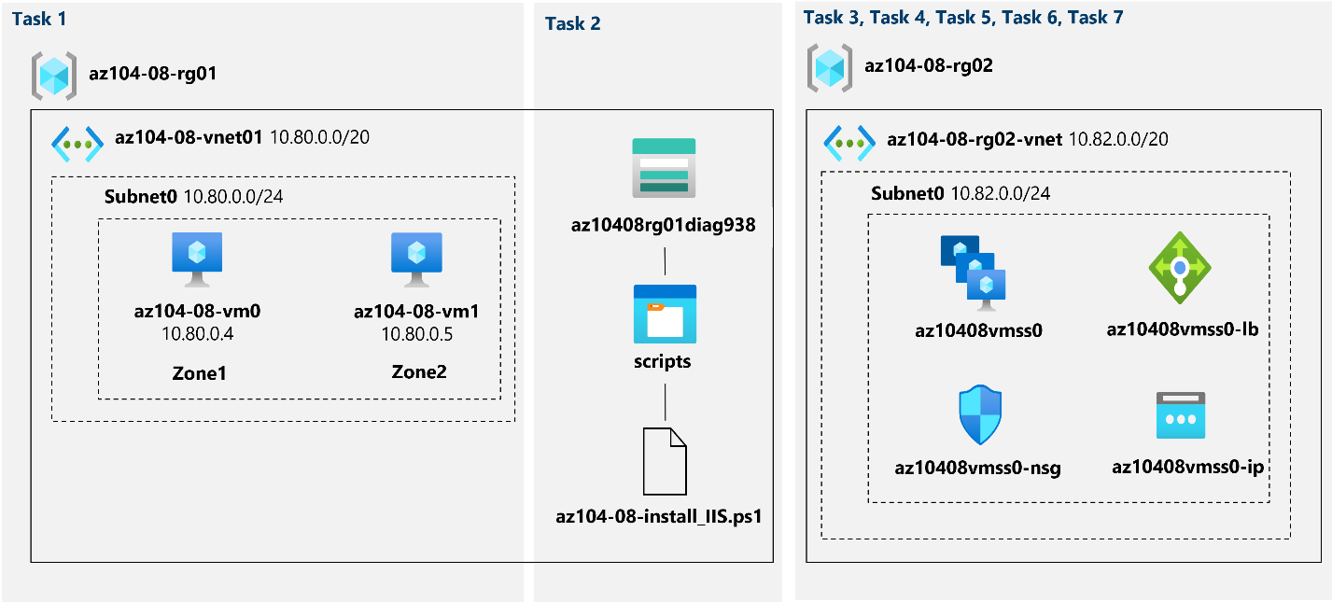

Task 1: Deploy zone-resilient Azure virtual machines by using the Azure portal and an Azure Resource Manager template.

In this task, we will deploy Azure virtual machines into different availability zones by using the Azure portal and an Azure Resource Manager template:

Here, we create all of our virtual machines with the required settings and deploy them:

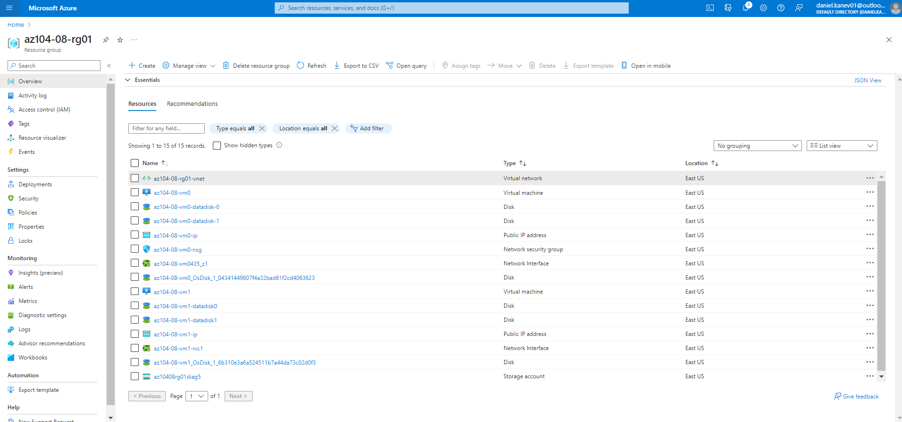

Task 2: Configure Azure virtual machines by using virtual machine extensions.

In this task, you will install Windows Server Web Server role on the two Azure virtual machines you deployed in the previous task by using the Custom Script virtual machine extension:

First, we create a new storage account and upload the required script to it. Then, on the vm0 virtual machine, we install an extension called Custom Script Extension, configure it and use the script from the storage account. Lastly, we verify that everything was successful by running a RunPowerShellScript command:

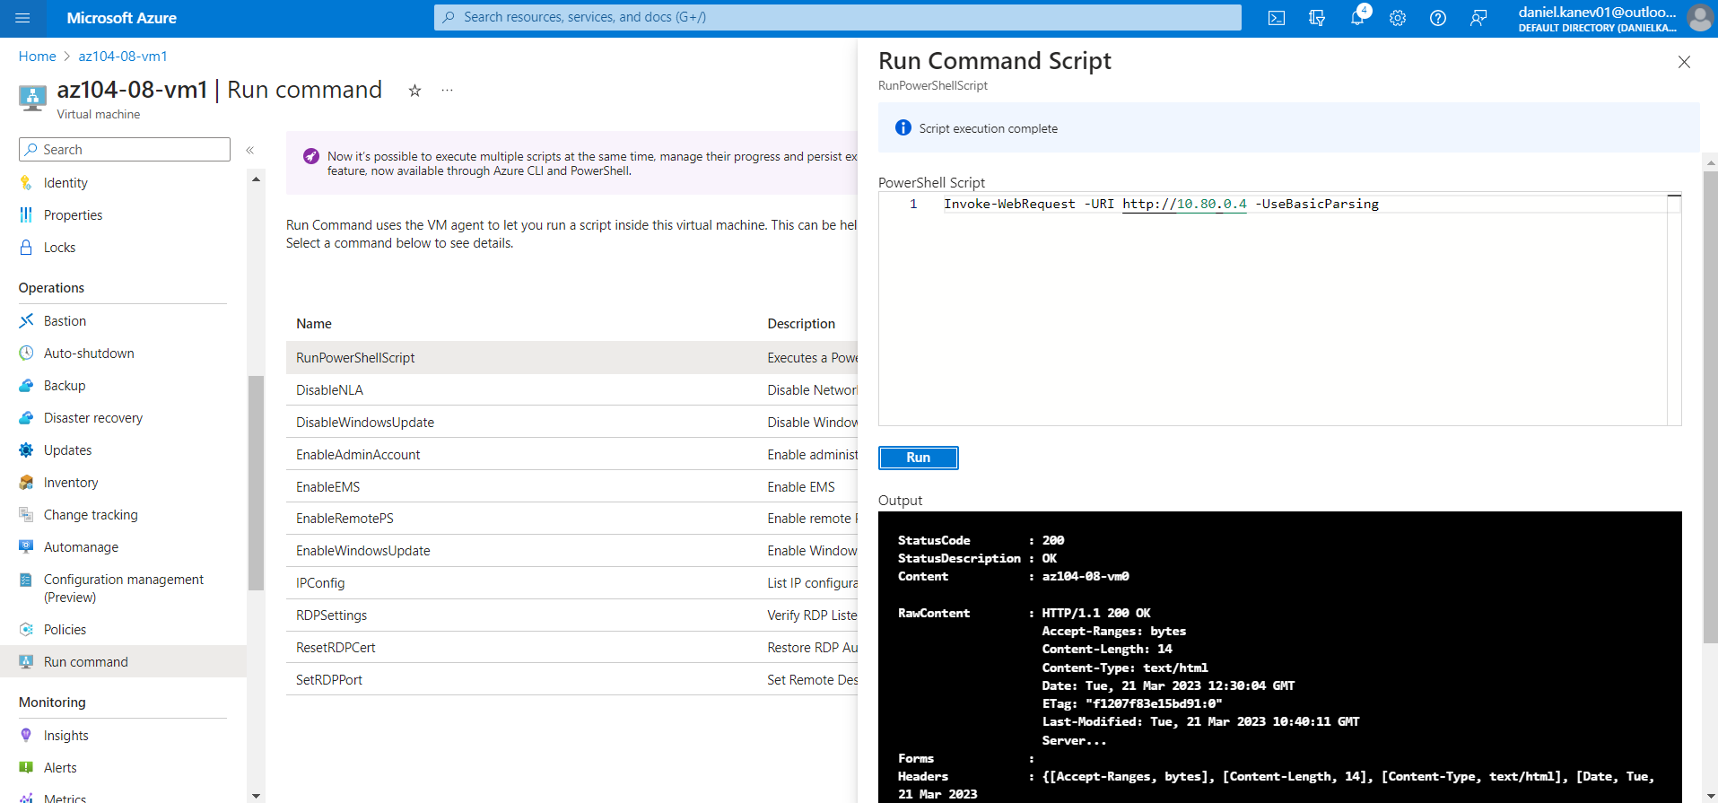

Task 3: Scale compute and storage for Azure virtual machines.

In this task, we will scale compute for Azure virtual machines by changing their size and scale their storage by attaching and configuring their data disks.

To begin with, we change the vm0 virtual machine disk size, create and attach a new one to it as well (to the vm) and run a command script to create a new drive that contains the 2 new attached disks. Then, on the vm1 virtual machine we export a new template via the Automation section -> Deploy -> Custom deployment -> Edit template. We change the disk size, and create 2 disks attached to the vm1 using the code from the example. And lastly, with running a PowerShellScript again, we create a new drive that consist of the 2 newly attached disks:

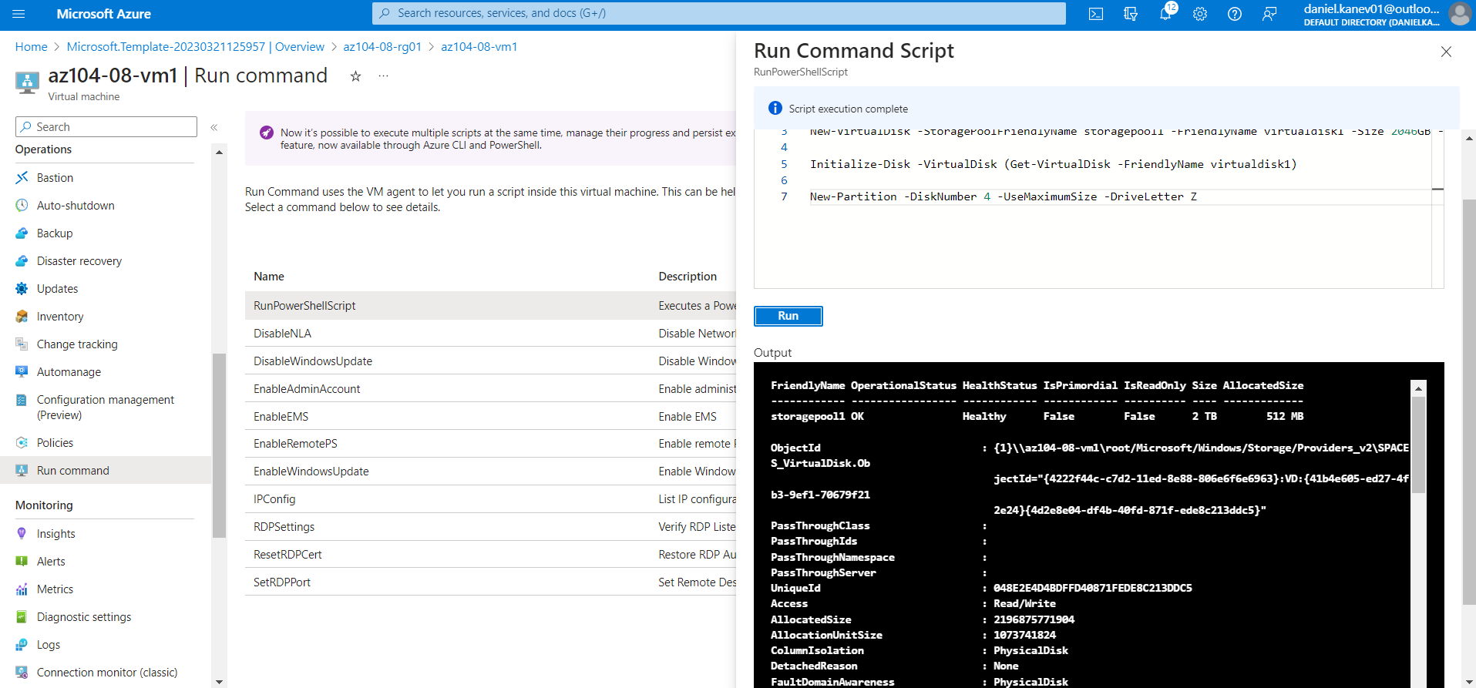

Task 4: Register the Microsoft.Insights and Microsoft.AlertsManagement resource providers.

This is done by executing 2 commands in the Azure Cloud Shell -> Powershell:

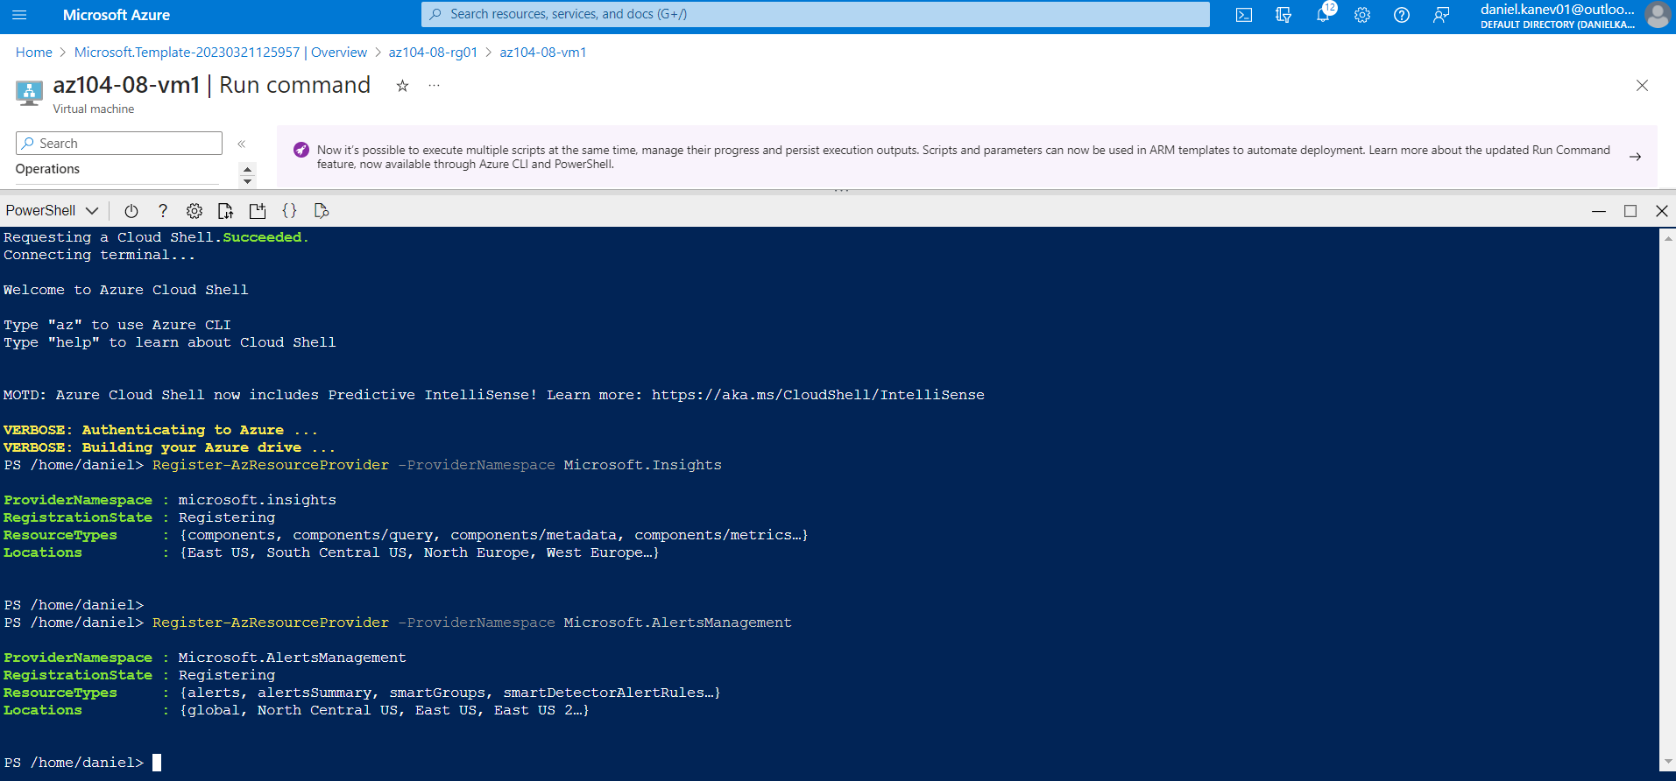

Task 5: Deploy zone-resilient Azure virtual machine scale sets by using the Azure portal.

In this task, we will deploy Azure virtual machine scale set across availability zones by using the Azure portal:

Here, we just create a new virtual machine scale set with the required settings:

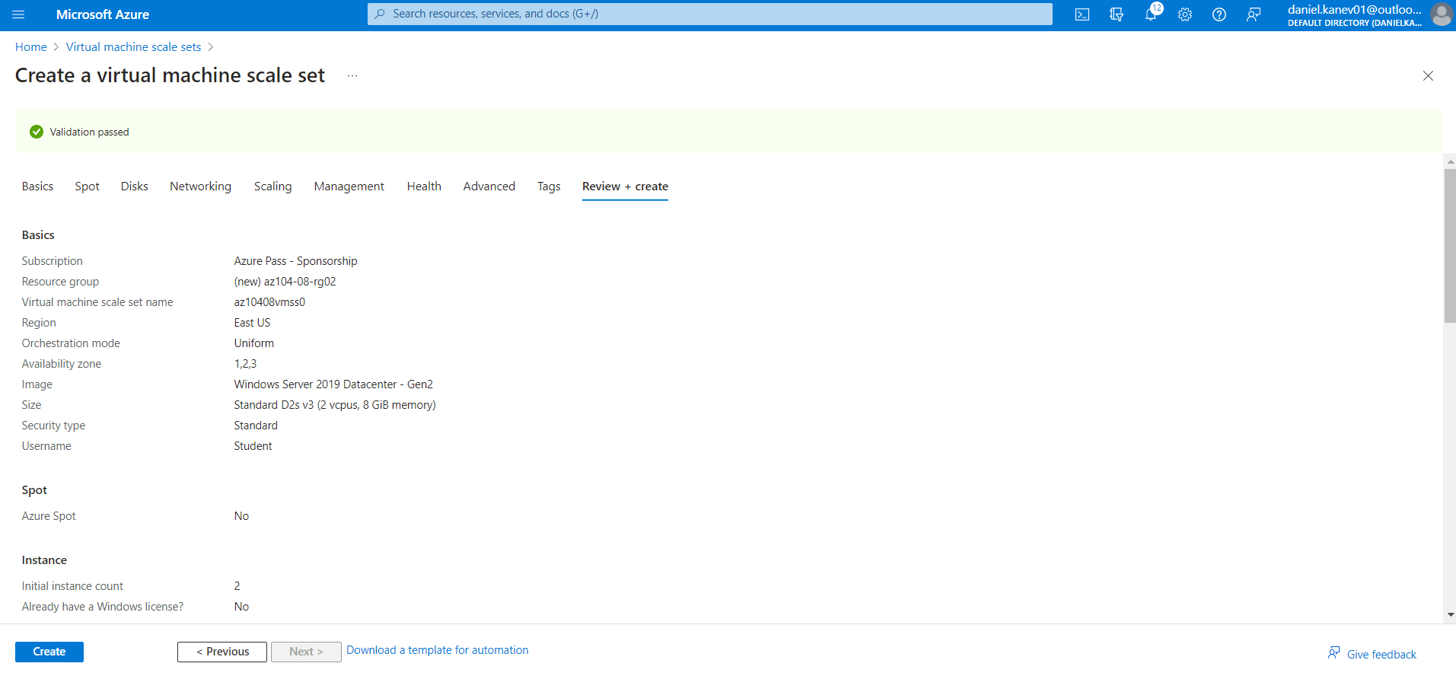

Task 6: Configure Azure virtual machine scale sets by using virtual machine extensions.

In this task, we will install Windows Server Web Server role on the instances of the Azure virtual machine scale set you deployed in the previous task by using the Custom Script virtual machine extension.

We start of by selecting the storage account from the previous task, adding a new container in it and attaching the required script. Then we add the correct custom script to the vmss0 scale set and check it’s Public IP through the Load balancer.

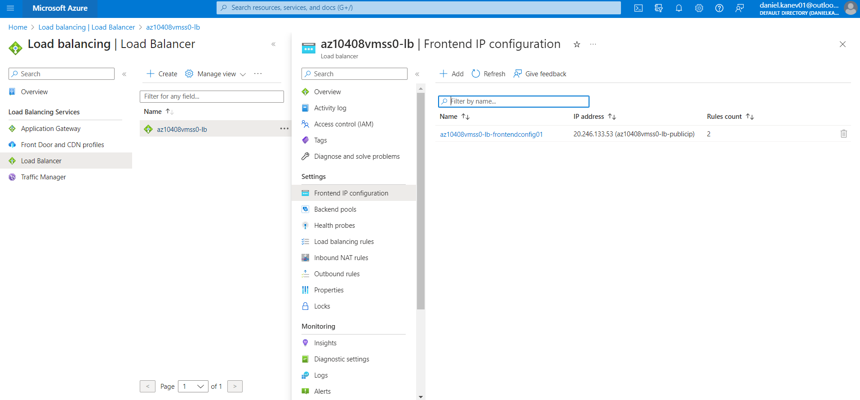

If we check through a browser, the page displays the correct name of one of the instances of the Azure virtual machine scale set az10408vmss0.

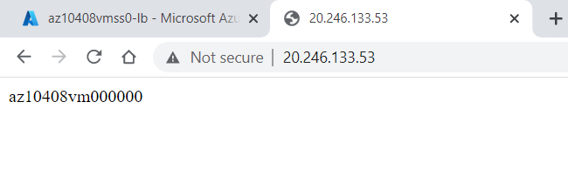

Task 7: Scale compute and storage for Azure virtual machine scale sets (optional).

In this task, you will change the size of virtual machine scale set instances, configure their autoscaling settings, and attach disks to them:

First, we change the size and scaling of the vmss0 scale set by following the steps, and then check it’s Public IP address by running a Shell command. Then attach a new disk to it, upgrade it, and uninstall the CustomScriptExtension. Lastly, through the Shell pane again, we upload the required file, and run a few commands to display the content of the script and execute it to configure disks of the Azure virtual machine scale set.

